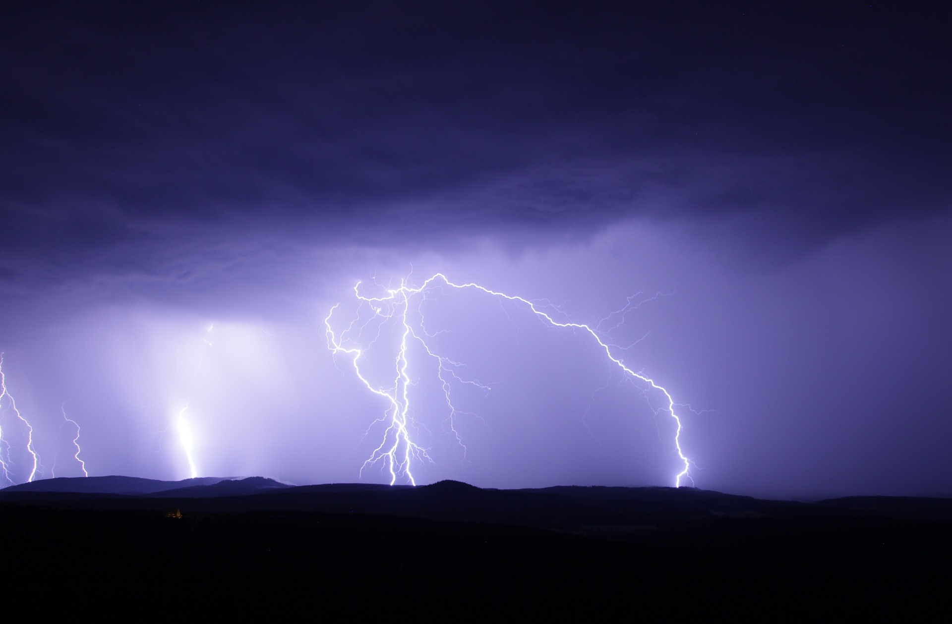

|  |
| --- |
| WeatherPy  Report |
|  |
| July 17  Authored by: Jessica Etchechury |

# INTRODUCTION

# The following report is a summary of the analysis of the weather of 500+ cities across the world of varying distance from the equator. The question we aimed to answer using the data set was “What’s the weather like as we approach the equator?”

# DATA OVERVIEW

# In order to gather the weather data of 500+ cities across the world Citipy, a Python library, and the OpenWeatherMap API were used.

# Before examining the scatterplots below it is important to note that the equator is represented by 0 on the x-axis (latitude). Looking at the ‘City Latitude vs. Max Temperature scatterplot we can see that cities located nearer to the equator have higher maximum temperatures. We can also see that as latitude increases (representing north of the equator) the maximum temperature decreases much more rapidly than as the latitude decreases (representing south of the equator).

# There appears to be a slight correlation between humidity and latitude near the equator. Most cities located near the equator appear to have a humidity around 100%.

RECOMMENDATIONS/ CONCLUSIONS

# In order to make concrete conclusions regarding the relationship between latitude and the other three variables examined: humidity, latitude, and wind speed, it may be beneficial to examine a larger sample of cities. It would have also been helpful to examine and possibly remove any outliers such as the 300% humidity point. One limitation encountered with the data set was that most of the cities are in urban, dense clusters which creates a biased data set as it excluded weather in rural areas.